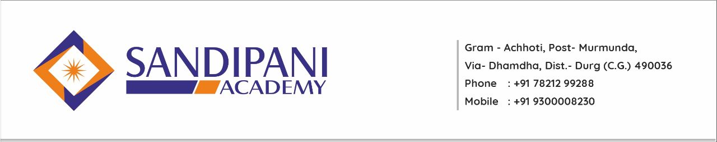
National Webinar/Seminar
S.NO. | PROGRAM NAME | MONTH | DATE
1. | Challenge & Opportunities of Higher System | August | 29/08/2020
2. | Gender Sensitization | April | 24/04/2021
3. | My Role in Environment Conservation | June | 08/06/2021
4. | Yoga’s Impact in Our Life | June | 25/06/2021
5. | The Impact of New Education Policy(2020) on The Higher Education Sector | November | 30/11/2021
6. | National Conference on Education, Research & Innovation | February | 01/02/2023-02/02/2023

